**EXPERIMENT -1**

**EXP NO 1:** CREATE A SIMPLE CLOUD SOFTWARE APPLICATION AND PROVIDE IT AS A SERVICE USING ANY CLOUD SERVICE PROVIDER TO DEMONSTRATE SOFTWARE AS A SERVICE (SAAS).

**DATE:**

**AIM:** To create a simple cloud software application and provide it as a service using any cloud service provider to demonstrate software as a service (saas).

**PROCEDURE:**

Step1: Goto Zoho.Com

Step 2: Login To the Zoho.Com

Step 3: Select One Application

Step 4: Enter Application Name

Step 5: Created New Application

Step 6: Select One Form

Step 7: The Software Hase Been Created.

Form 1: Doctors appointment form.

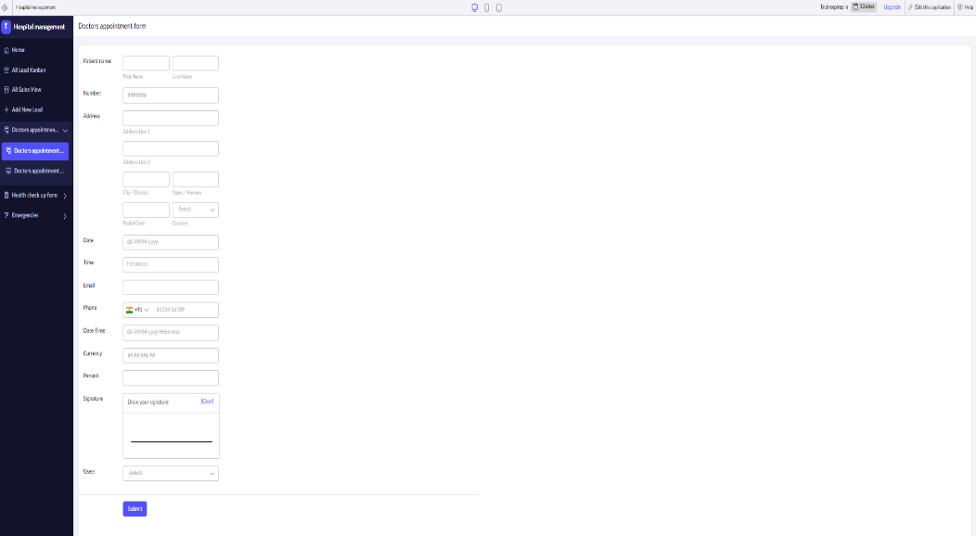

Form 2: Health checkup form.

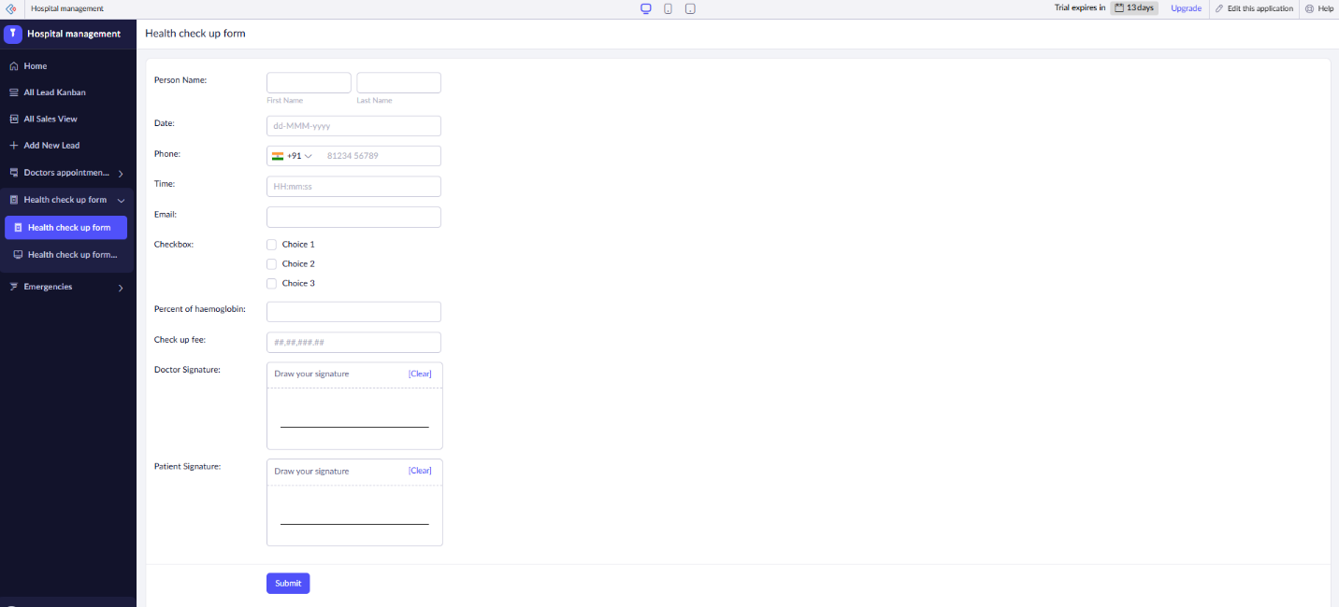

Form 3: Emergency form.

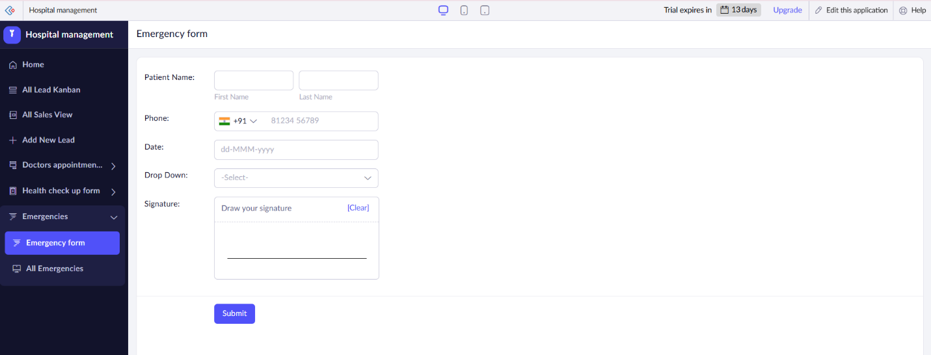

Form 1: Doctors appointment form.

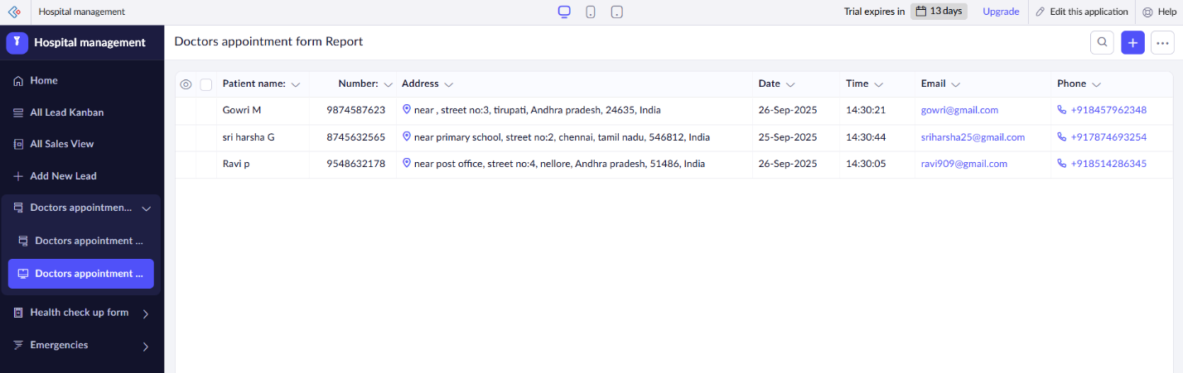

Form 2: Health checkup form.

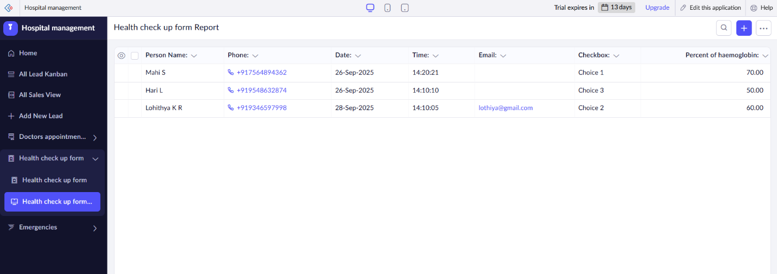

Form 3: Emergency form.

Result: A SaaS solution is a web‑hosted application delivered over the internet, where the provider manages infrastructure, deployment, updates, and scaling, and users access it via subscription without needing to install or maintain it themselves.